Coupons project client side
Requirements coverage

Table of Contents
General notes 2
Test coverage 2
Admin login - /rest/login 3
Create company - /rest/register/createCompany/ 5
Delete company - /rest/api/companys/deleteCompany/companyId/1 8
Update company - / rest/api/companys/updateCompany 10
Create customer - /rest/register/createCustomer/ 12
Delete customer - /rest/api/customers/deleteCustomer/customerId/1 14
Update customer - /rest/api/customers/updateCustomer/customerId 15

General notes
- Rest approach is not taken in classical methodology, but in functional approach
Each activity will have own unique @Path URL.

For example createCompany will be under “rest/api/companies/createCompany”
This approach was taken as it was found practical.

Test coverage
The document will go through the requirements described in the accomplished project document

Admin login - /rest/login
Login screen
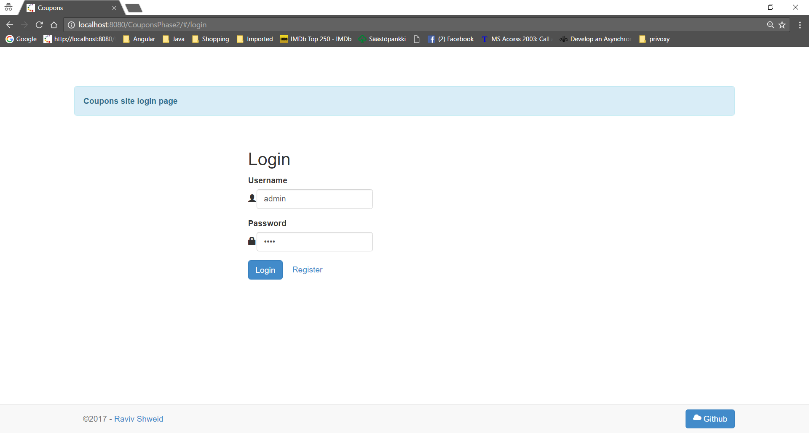

Login error:
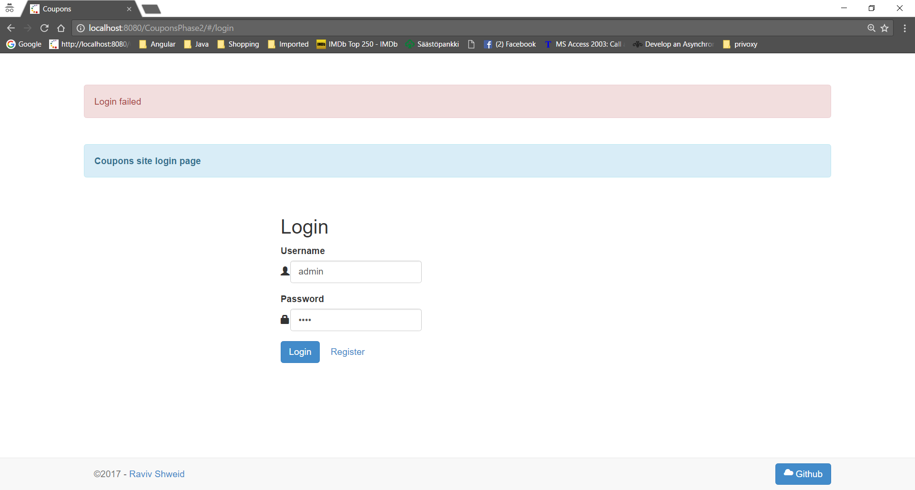
Admin login success:
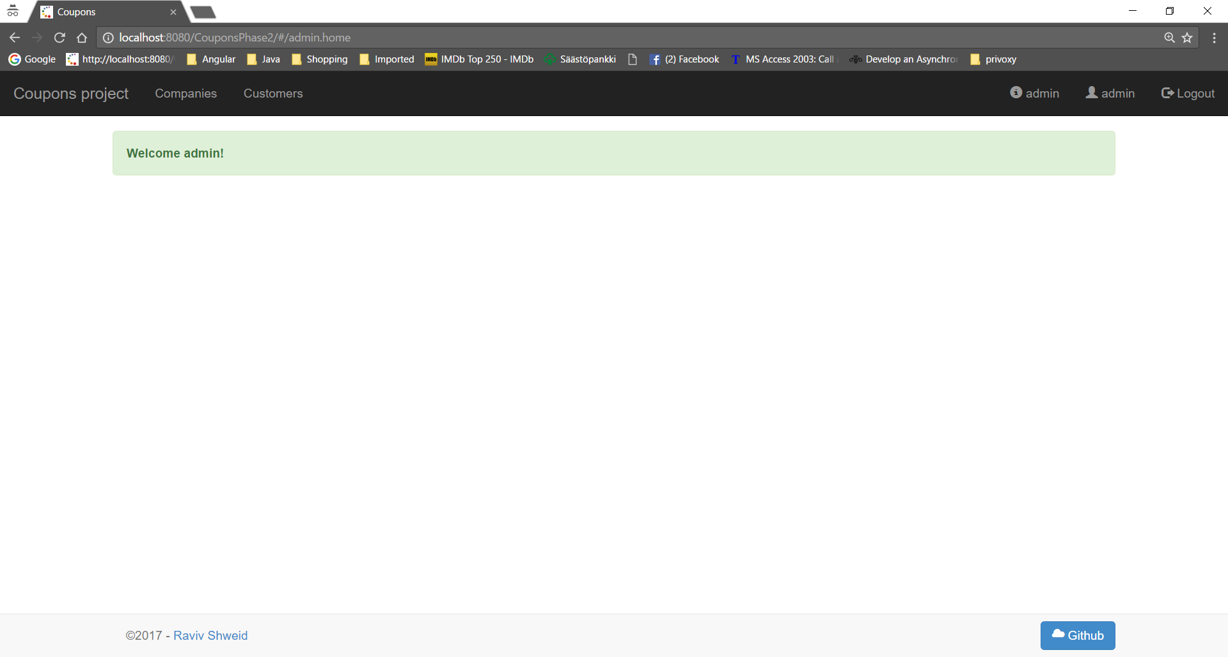

Create company - /rest/register/createCompany/
In this project I have use self-register approach as it is closer to real world approach
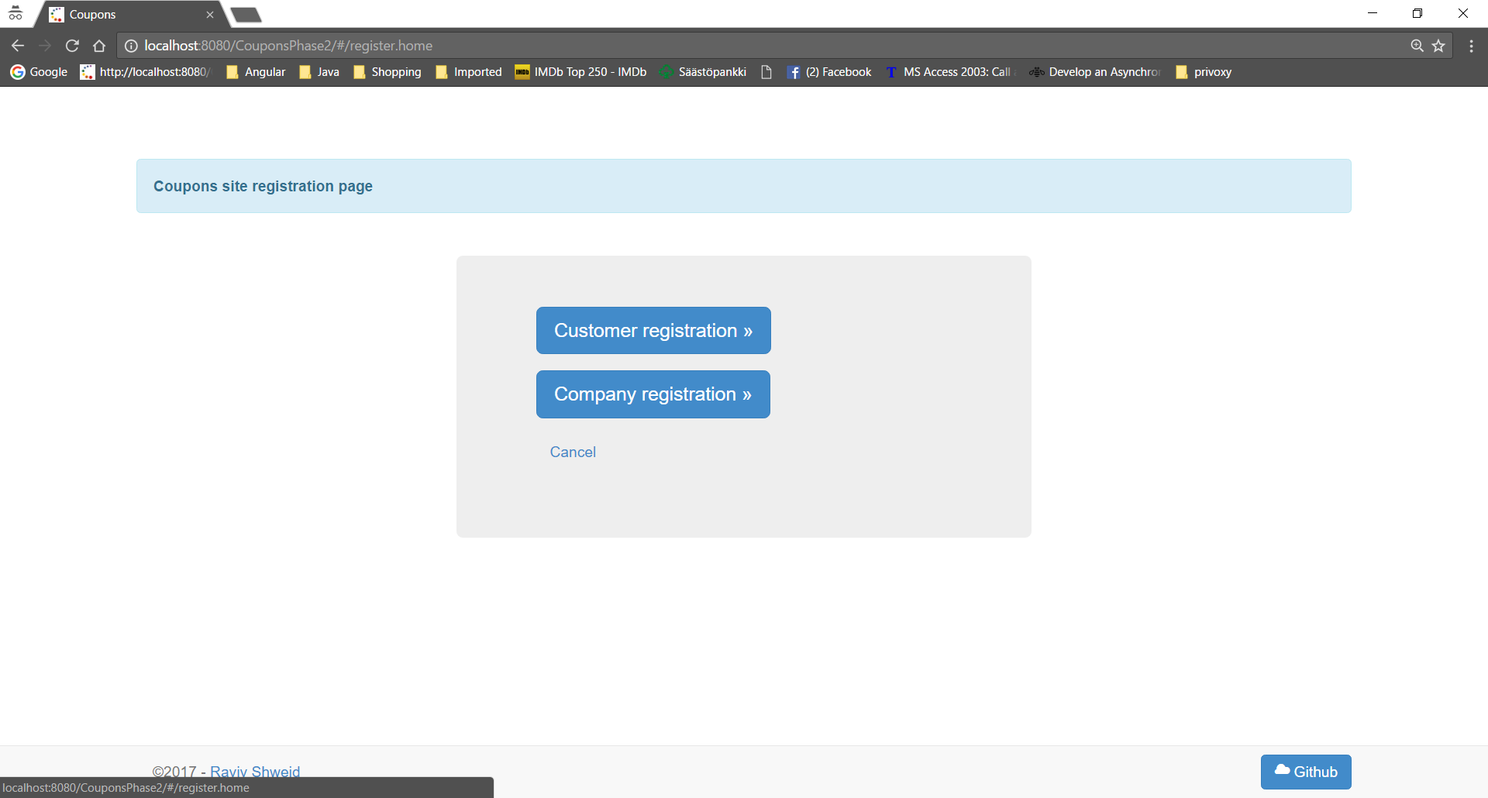

Invalid email:
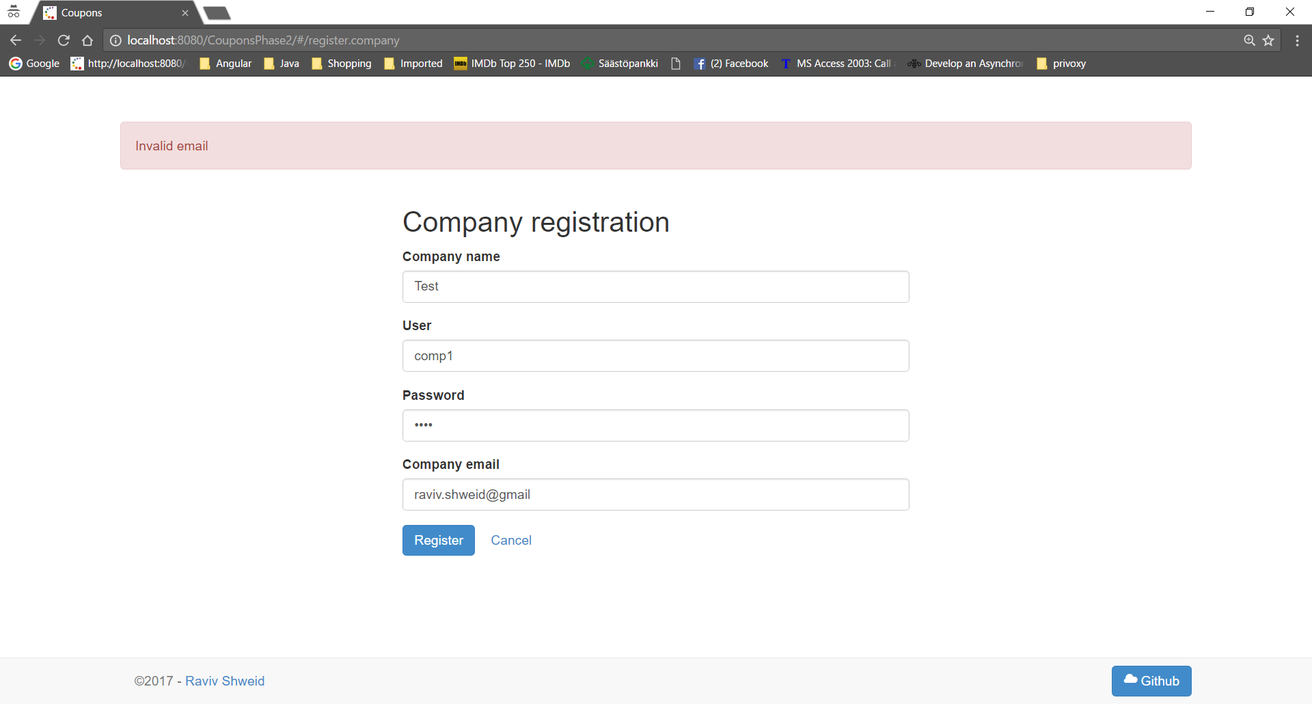
User already taken:
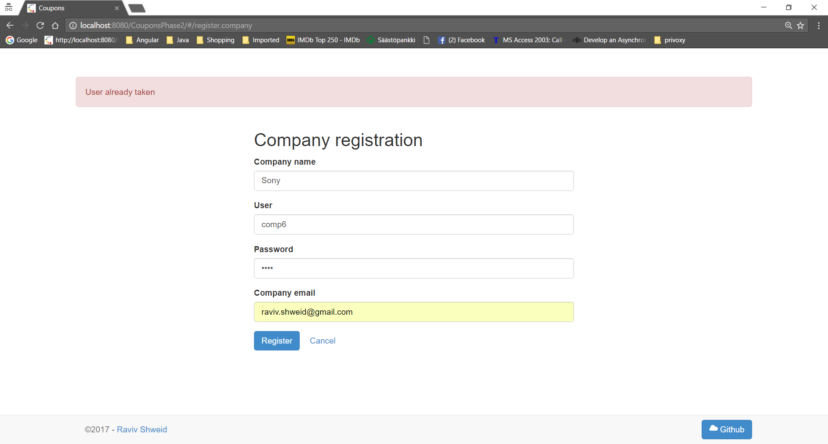

Company name already taken
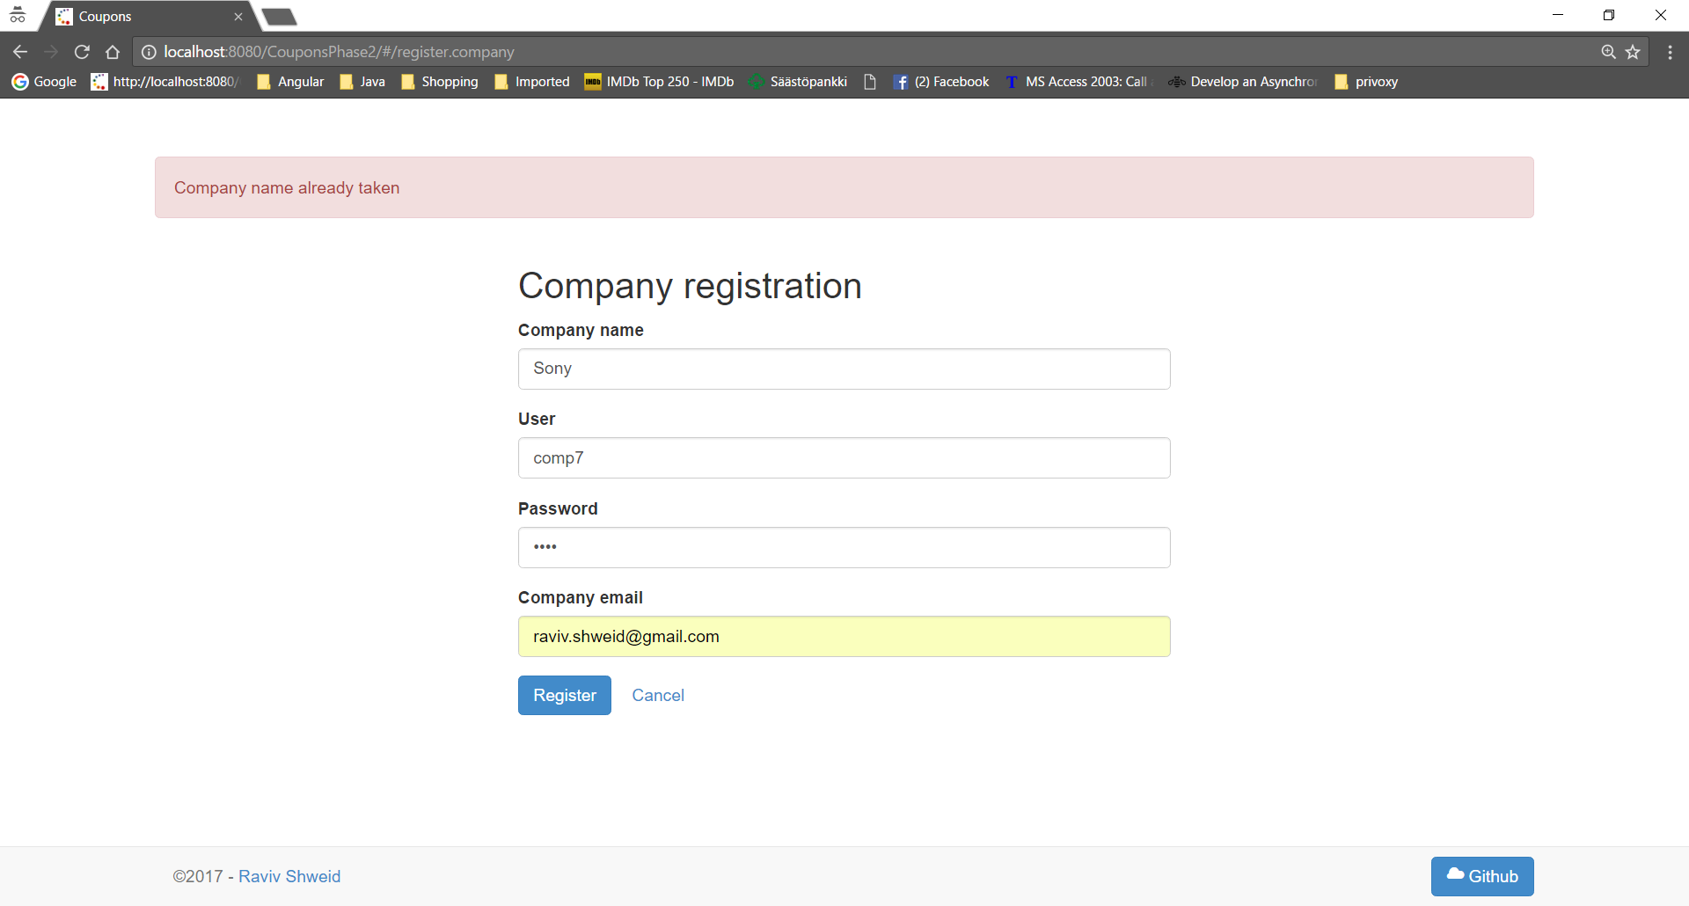

Company registration success immediate login:
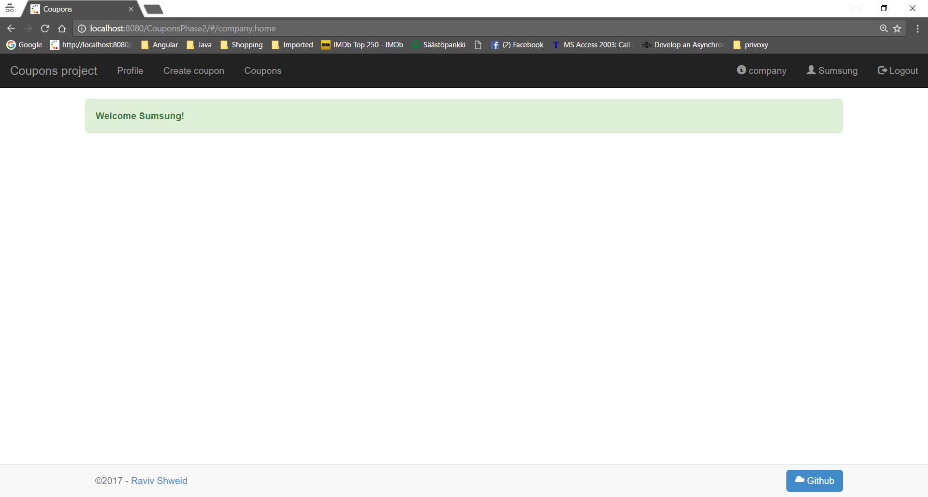

Delete company - /rest/api/companys/deleteCompany/companyId/1
Admin Delete Company: Companies menu item: Remove button:
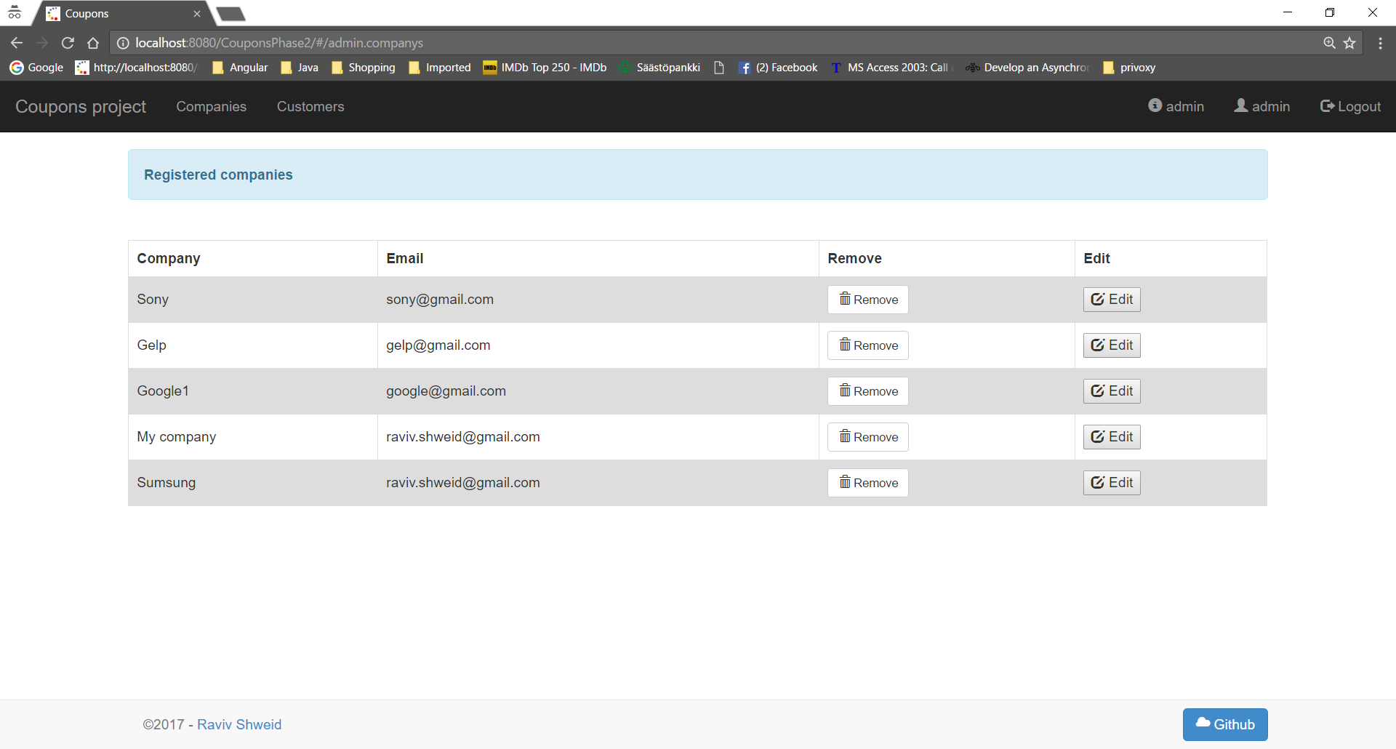

Remove: confirmation : No :
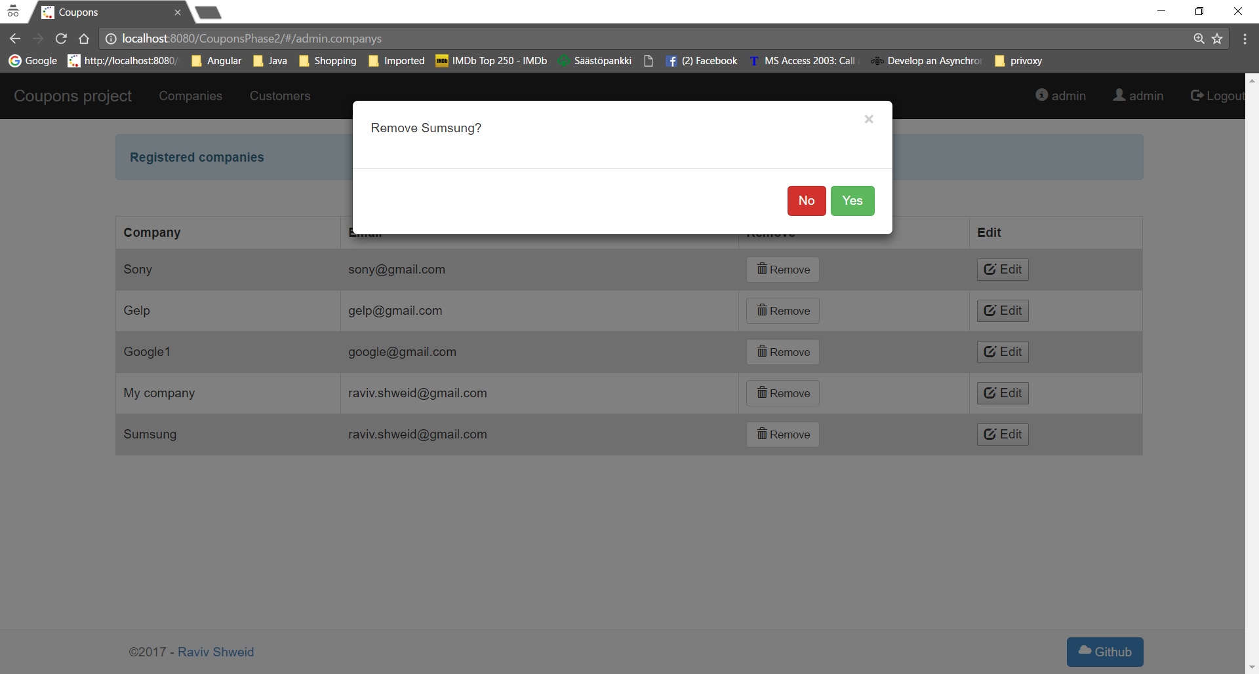

Remove: confirmation : Yes :
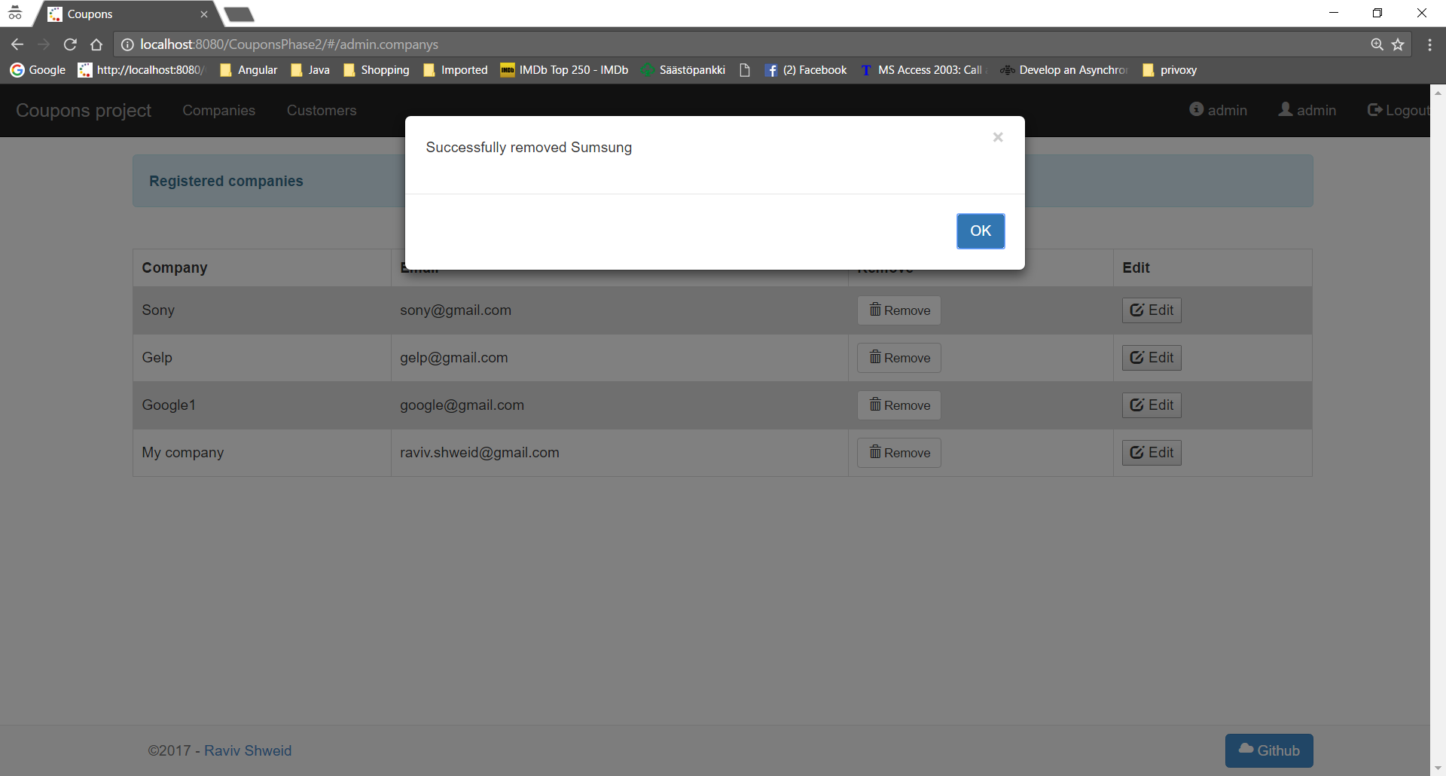

Update company - / rest/api/companys/updateCompany
Update company details failed : Company name already taken
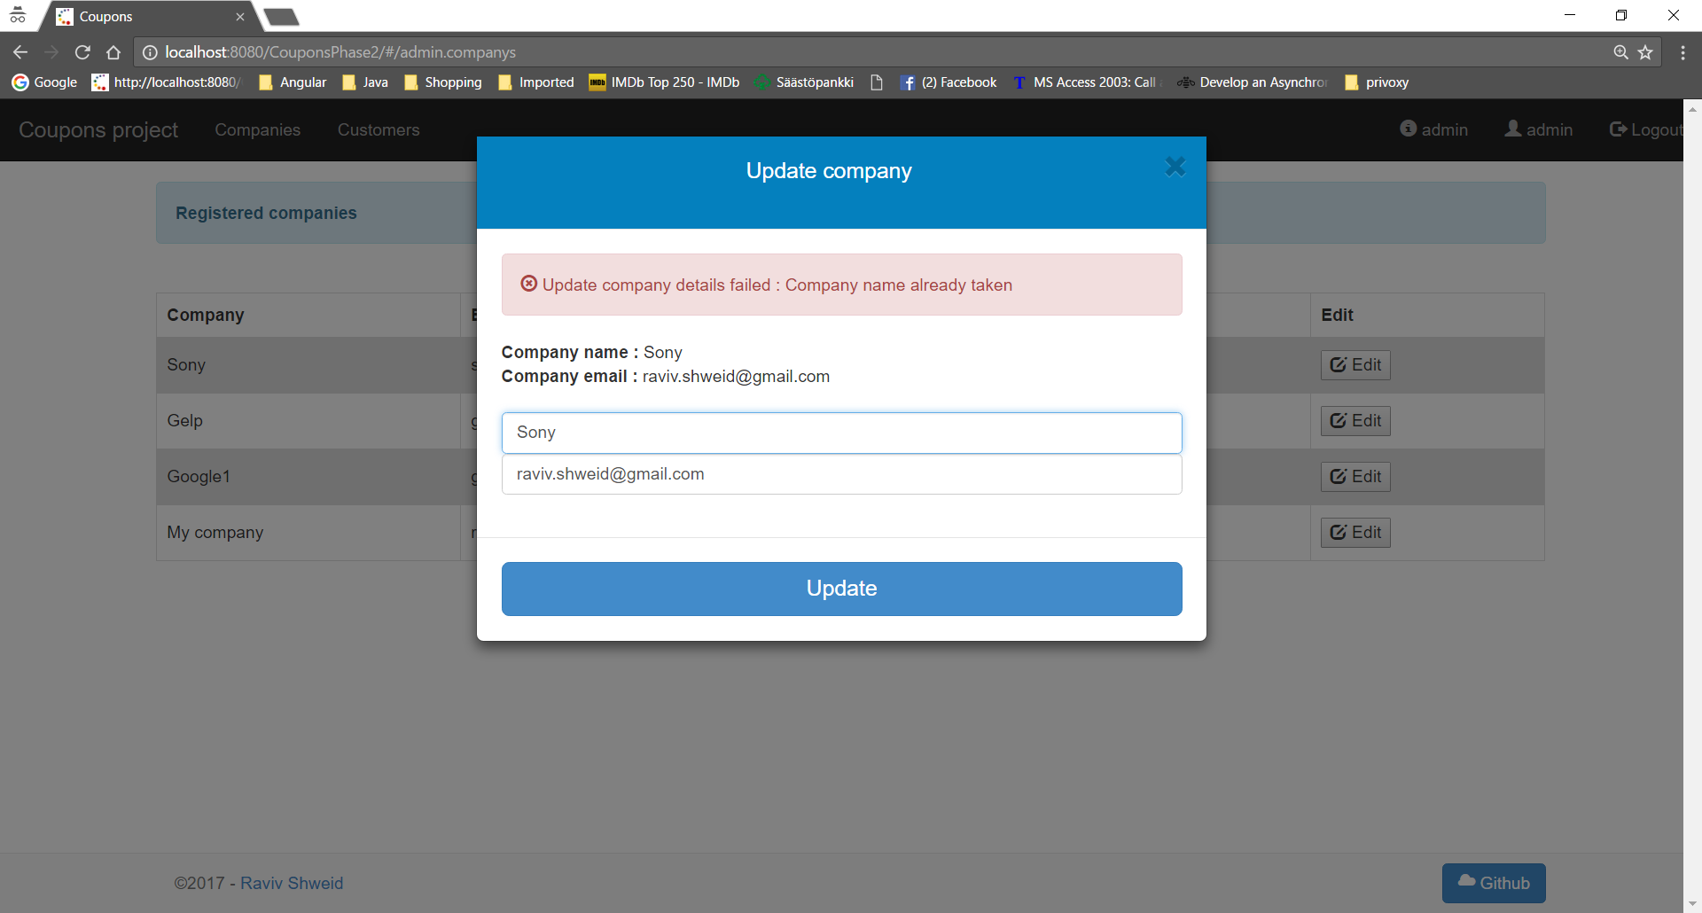

Update company details failed : Invalid email
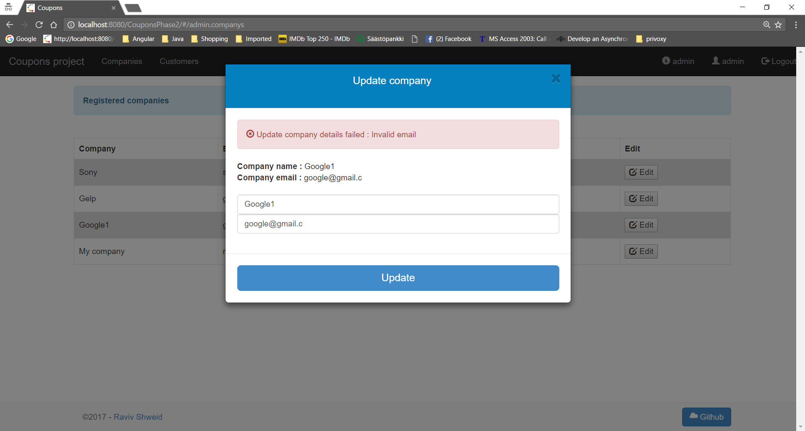

Successfully updated company details.

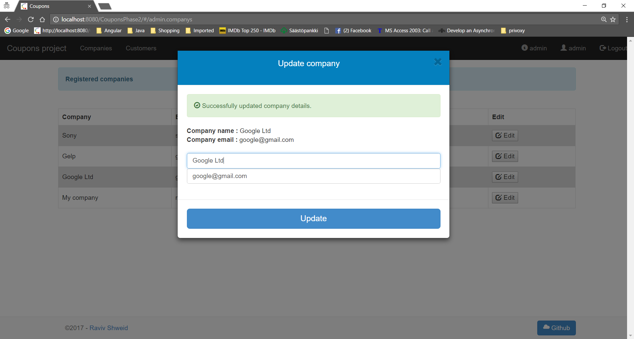

Create customer - /rest/register/createCustomer/
User already taken
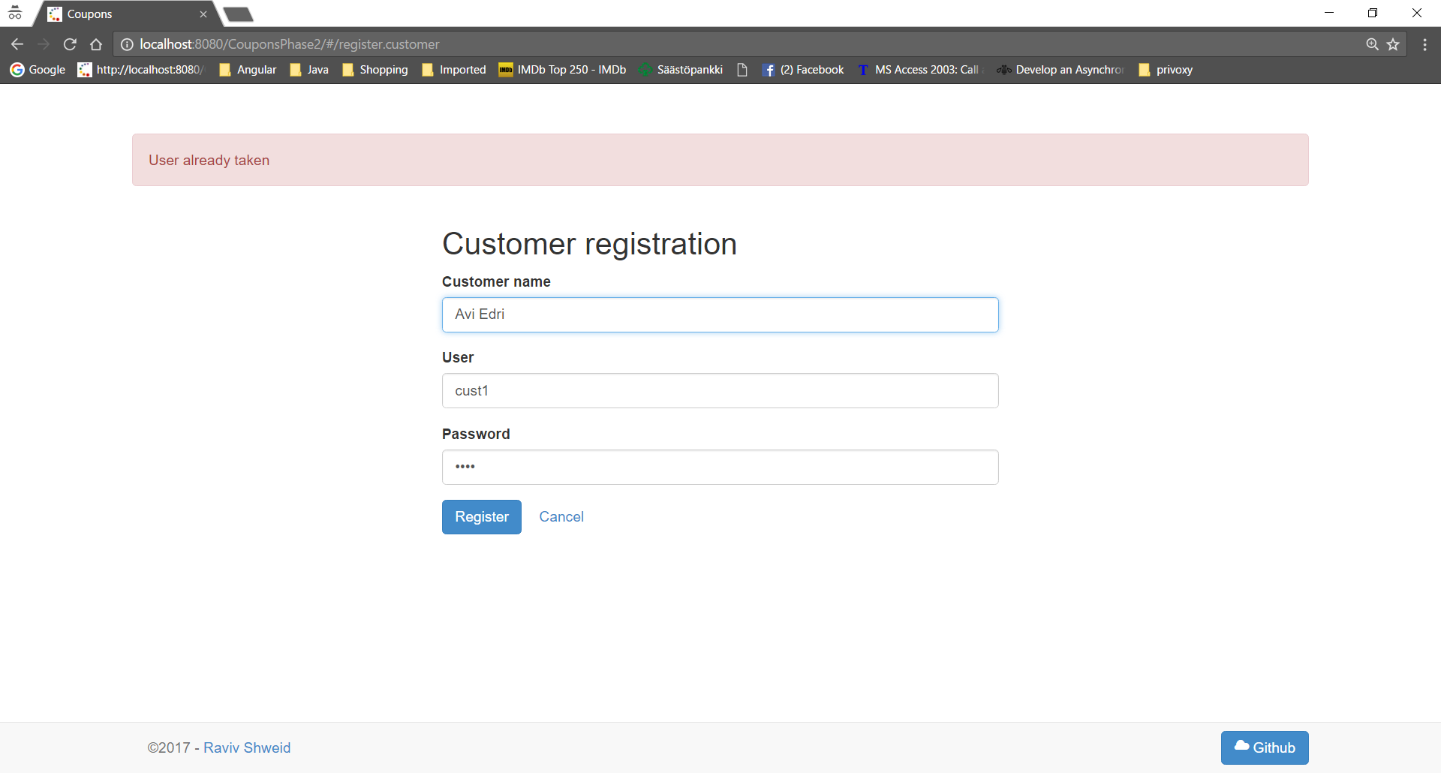

Customer name already taken
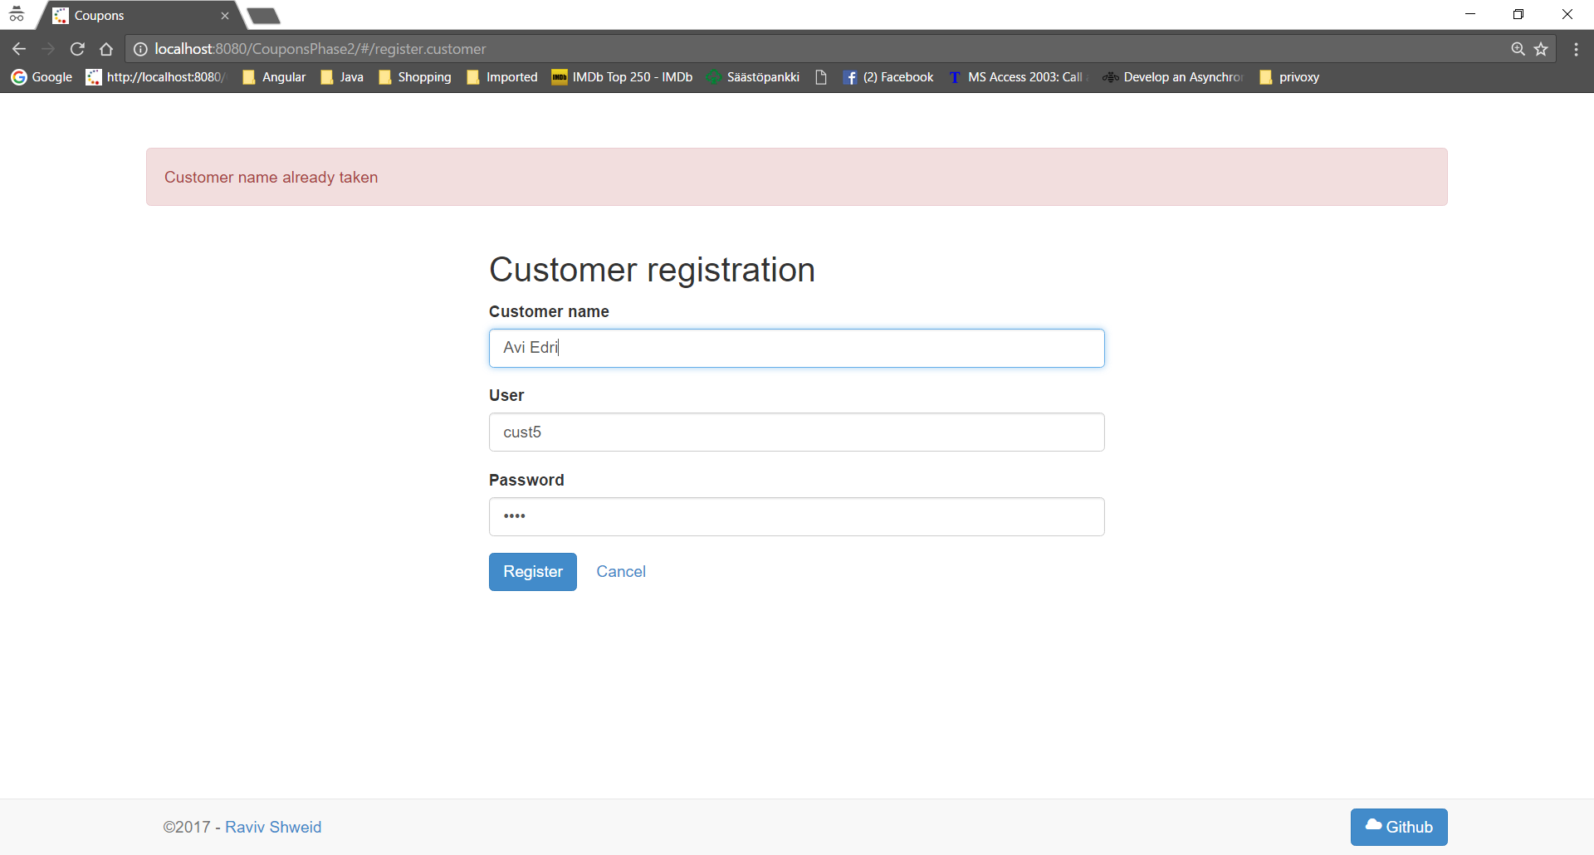

Success: immediate login: Welcome …
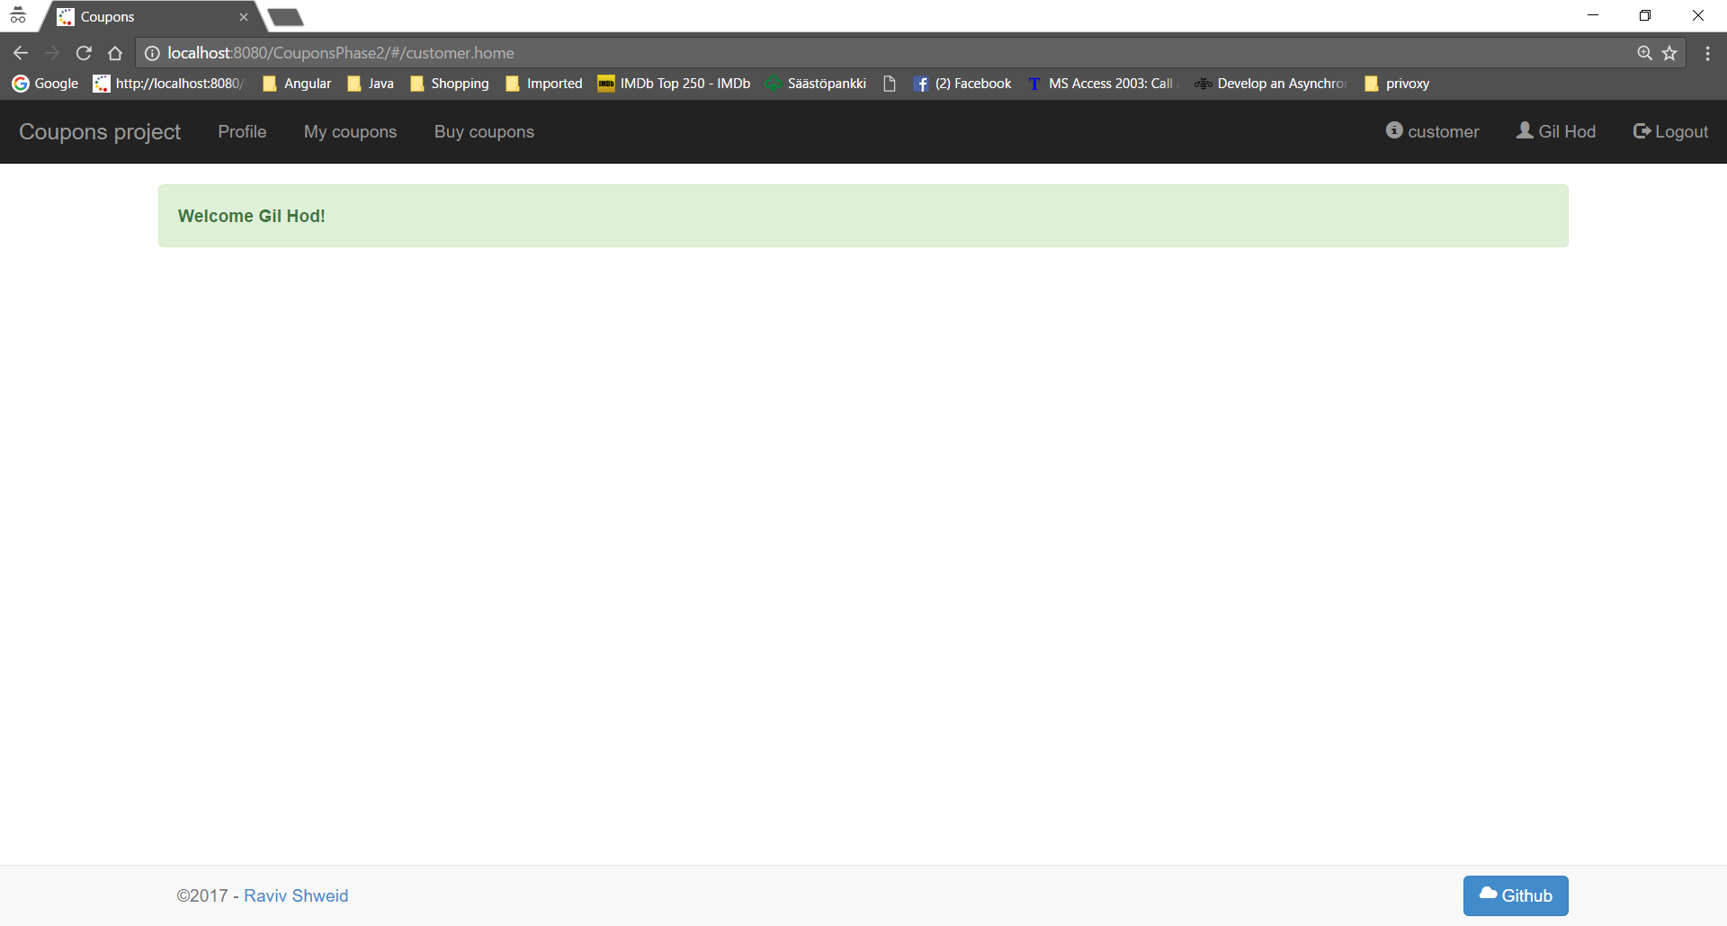

Delete customer - /rest/api/customers/deleteCustomer/customerId/1
Remove customer: confirmation: No
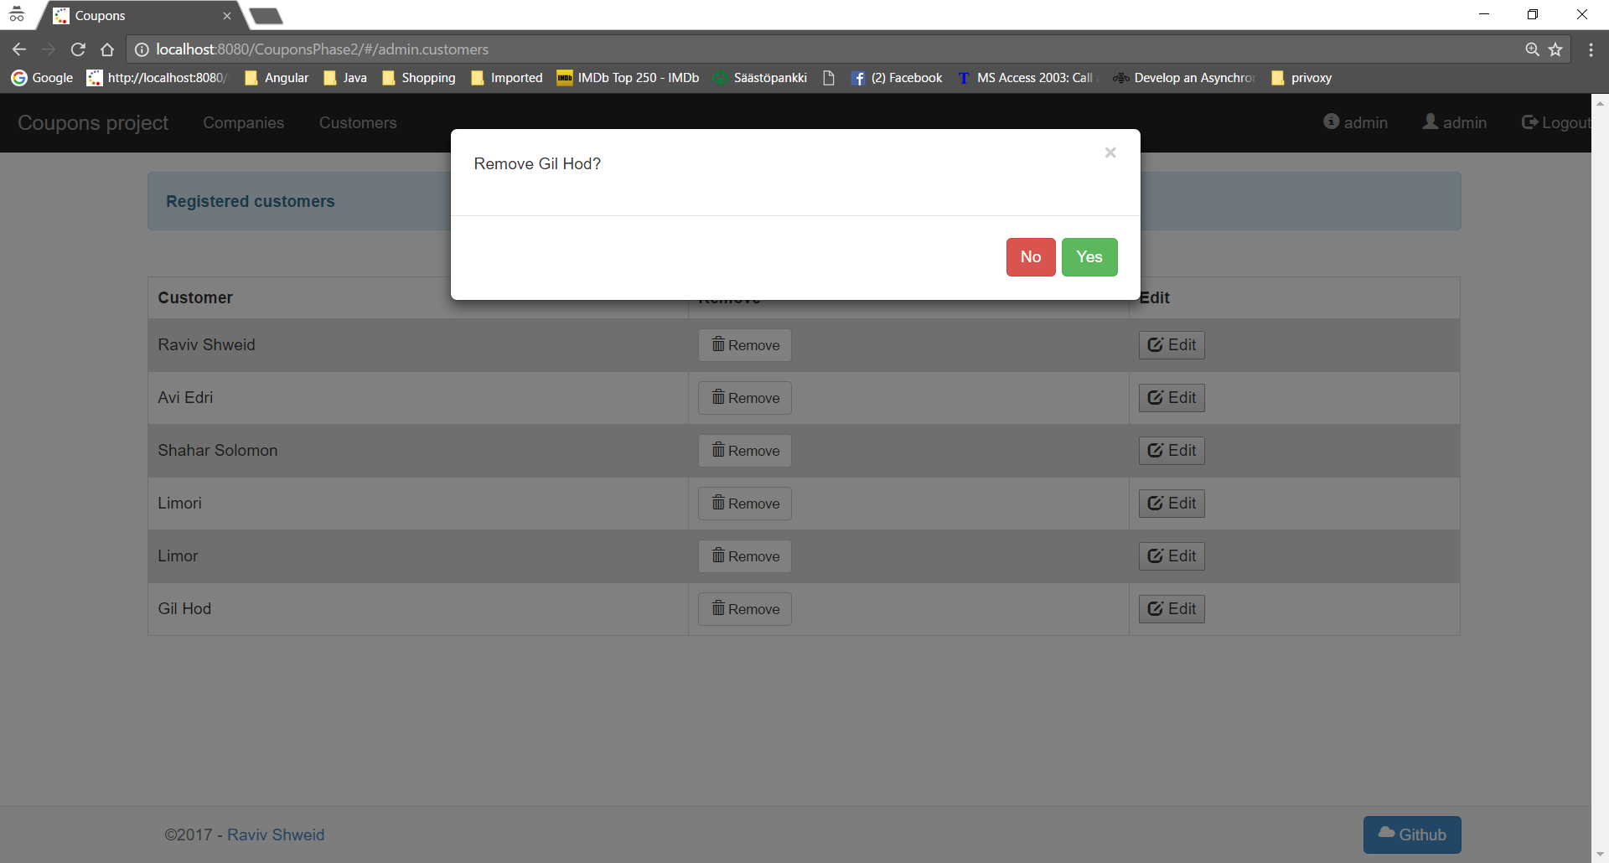

Remove customer: confirmation: Yes
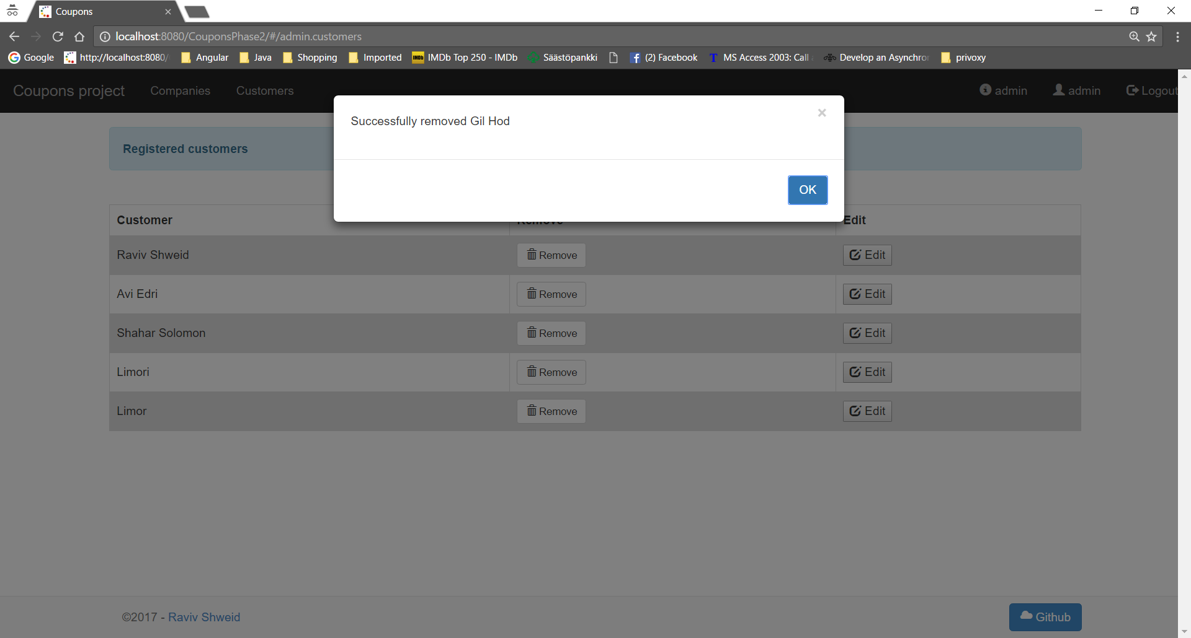

Update customer - /rest/api/customers/updateCustomer/customerId
Update customer details failed : Customer name already taken
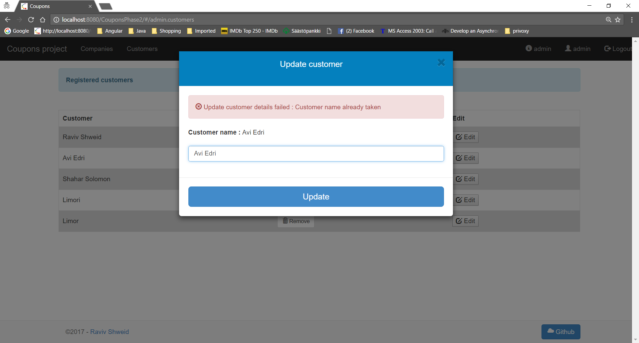

Successfully updated customer details.
